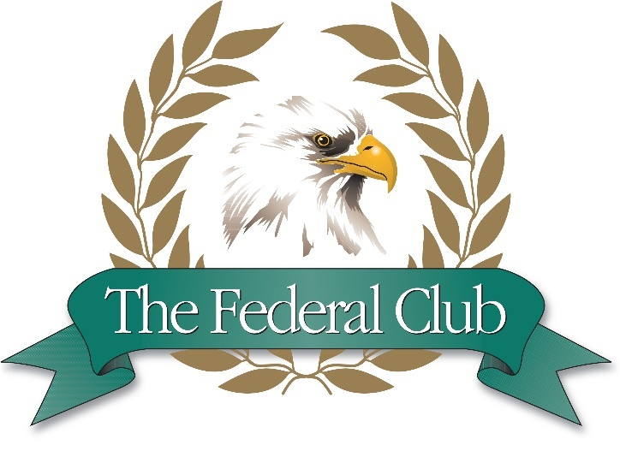

General Manager

The Federal Club

Glen Allen, VA 23059

About the Club:

The Federal Club is a private country club in southwest Hanover County, just north of Richmond, Virginia. The Federal Club opened in 2007 and moved into its new 25,000 square foot clubhouse in October 2016.

The Federal Club, an Original Arnold Palmer Signature Design, offers terrific views and challenging play for golfers. The golf course features bentgrass tees, greens, and fairways. The Federal Club is renowned for being one of the best conditioned courses in Virginia. In recent years, The Federal Club has installed additional teeing areas to satisfy the increased demand for family friendly golf.

The Federal Club offers a Trackman Golf Performance Center, two lit hard-surfaced tennis courts, and a beautiful swimming complex complete with a 25-yard pool, a kiddie pool and an adult-only pool. Our grill and bar staff will serve you poolside while you swim, play or lounge! The Federal Club offers dining, bar, banquet services and social functions.

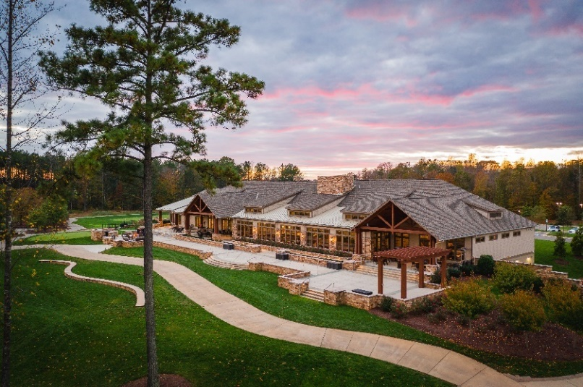
Position Description:

The General Manager is responsible for all day-to-day club activity. The General Manager will oversee and work closely with all department heads to include, but not limited to; Controller, Golf Course Superintendent, Head Golf Professional, Director of Instruction, Food & Beverage Manager, Executive Chef, Member Services Administrator and Ownership. The General Manager will oversee coordinating member services, member growth, dining & social events, and golf operations. The long-term objective is to continue to improve member satisfaction, club management, asset preservation and operations profitability. The ideal candidate will have a high degree of initiative and will demonstrate the ability to build, mentor and manage a successful staff and empower a cohesive team.

Key areas of responsibility include:
- The General Manager's primary responsibility is to ensure excellence in member service while overseeing the front and back of house staff and the physical property.
- Exhibit firm leadership of the staff, challenge the status quo, and think creatively
- Interview, hire, coach and counsel department managers in the efficient operation of their respective areas
- Candidates must be comfortable with member interactions and possess strong written and verbal communication skills, as well as excellent computer proficiency.
- Knowledge of food and wine is beneficial, as well as an understanding of and appreciation for the game of golf.
- Through personal leadership and example, establish a friendly, service-oriented approach to members that is exhibited by all departments.
- Team player
- Strong work ethic, integrity and professional demeanor
- Must be passionate about the hospitality industry and focused on creating amazing member experiences.
- Develop and follow a detailed annual operating Excel budget with the accountant, department heads and ownership.

Required Skills:

  - Excellent interpersonal skills that will enable candidate to develop strong member relationships.
  - Strong written and oral communication skills.
  - Good understanding of Club Operations budgeting and accounting.
  - Able to communicate effectively and professionally in both verbal and written formats.
  - Computer literate in MS Office products as well as POS systems and tee time management systems.

Experience / Qualifications:

Including, but not limited to, the following:

  - Candidate should have no less than three years of management experience in club, retail, food and beverage or other service industry.
- Previous experience being responsible for financial results and customer satisfaction
- College degree preferred
  - The successful candidate will have experience and demonstrated achievement in the managerial and technical skills necessary to maintain and enhance the performance of the club’s operations.
  - A proven track record of strong budgetary and operational management skills.
  - Excellent leadership, interpersonal and communication skills.
- Position requires the availability to work evenings, weekends, and holidays as needed.
Compensation and Benefits:
The club will provide a compensation and benefits package commensurate with experience and qualifications
This includes but not limited to:
- Base salary of $80,000-$90,000.
- Quarterly performance bonuses based on EBITDA.
- Allowance for continuing education and professional association dues.
- 100% Individual Health insurance
- Vacation and other benefits per company policies.
- Total Anticipated income for this position is $90,000-$105,000

Application Instructions:
Application Deadline: January, 12th, 2024

Please submit your cover letter, resume and references in a .pdf or .docx format directly to annegail@thefederalclub.com.

Employer does not wish to receive phone calls.

